Java with DSA-Day 10
Leader Element:

import java.util.*;
class leader{
public static void main(String[] args){
Scanner sc=new Scanner(System.in);
System.out.println("Enter the no of Elements: ");
int n=sc.nextInt();
System.out.println("Enter the array Element: ");
int[] arr=new int[n];
for(int i=0;i<n;i++){
arr[i]=sc.nextInt();
}
ArrayList<Integer> s=new ArrayList<>();
int max=arr[n-1];
s.add(max);
for(int i=n-2;i>=0;i--){
if(max<arr[i]){
max=arr[i];
s.add(max);
}
}
Collections.reverse(s);

for(int l:s){
System.out.print(l+" ");
}
}
}

Output:
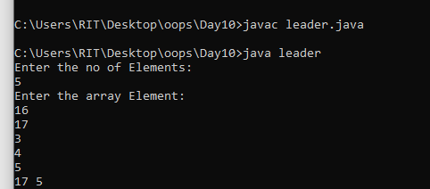

Union and Intersection Of a Two String:
import java.util.*;
class set1{
public static void main(String[] args){
Scanner sc=new Scanner(System.in);
System.out.println("Enter the String: ");
String str=sc.nextLine();
System.out.println("Enter the String: ");
String str1=sc.nextLine();
Set<Character> s=new LinkedHashSet<Character>();
for(int i=0;i<str.length();i++){
char ch=str.charAt(i);
s.add(ch);
}
System.out.println(s);
Set<Character> s1=new LinkedHashSet<Character>();
for(int i=0;i<str1.length();i++){
char ch=str1.charAt(i);
s1.add(ch);
}
System.out.println(s1);
/*System.out.println("Union Elements: ");
for(char ch:s1){
s.add(ch);
}*/
System.out.println(s);
System.out.println("Intersection Elements: ");
for(char ch:s1){
if(s.contains(ch)){
System.out.print(ch+" ");
}
}
}
}
Output:
Intersection:
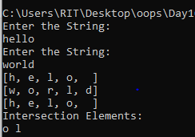
Union:
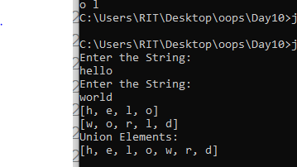
Union and Intersection Of a Two Array:
import java.util.*;
class set2{
public static void main(String[] args){
int[] arr1={1,2,3,4,5};
int[] arr2={2,4,7,9,5};
Set<Integer> s=new LinkedHashSet<Integer>();
for(int i=0;i<arr1.length;i++){
s.add(arr1[i]);
}
System.out.println(s);
Set<Integer> s1=new LinkedHashSet<Integer>();
for(int i=0;i<arr2.length;i++){
s1.add(arr2[i]);
}
System.out.println(s1);
/*System.out.println("Union Elements: ");
for(int num:arr2){
s.add(num);
}
System.out.println(s);*/
System.out.println("Intersection Elements: ");
for(int num:arr2){
if(s.contains(num)){
System.out.print(num+" ");
}
}
}
}

Output:
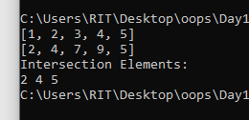

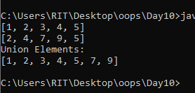

Check Whether the Array Contains the Duplicate With in a window:

import java.util.*;
import java.util.ArrayDeque;
class win{
public static void main(String[] args){
Scanner sc=new Scanner(System.in);
System.out.println("Enter the no of Elements: ");
int n=sc.nextInt();
System.out.println("Enter the array Element: ");
int[] arr=new int[n];
for(int i=0;i<n;i++){
arr[i]=sc.nextInt();
}
System.out.println("Enter the Window size: ");
int k=sc.nextInt();
Set<Integer> s=new LinkedHashSet<Integer>();
for(int i=0;i<=n;i++){
if(s.contains(arr[j])){
System.out.println("True");
return;
}
s.add(arr[j]);
if(s.size()>k){
s.remove(arr1[i-k]);
}
}
System.out.println("False");
}
}
Output:
